**Part1: critical appraisal of the report**

**Introduction --**

The report chosen by me for critical appraisal is Cancer and its impact in different parts of the world. This report was first published in July 2015 by Max Roser and Hannah Ritchie which was last revised in March 2018. It is a statistical summary which helps us understand the prevalence of cancer across the world’s population by the help of different kind of graphs. The content of this article and data visualizations rely on work from many different people and organizations which can be cited as –

*Max Roser and Hannah Ritchie (2019) - "Cancer". Published online at OurWorldInData.org. Retrieved from: 'https://ourworldindata.org/cancer' [Online Resource]*

The data for this report is annually collected over the years starting from 1990’s which has been used in various charts to make the readers understand about the spread of Cancer and its increasing impact on the world. The writer has used the line graph to show the share of population with cancer over different years from 1990 to 2016 for different countries. It has used different kinds of charts to make a study on types of Cancer and its percentage of prevalence in different countries. “Cancers are defined by the [National Cancer Institute (NCI)](https://www.cancer.gov/about-cancer/understanding/what-is-cancer) as a collection of diseases in which abnormal cells can divide and spread to nearby tissue”. The cancer can spread to different body parts through the blood and lymph causing different range of cancer types.

**Evaluation** –

This report has used marked line graph to present the share of population with cancer in different countries after standardizing the age. Impact of cancer across different geographical regions ranges from 0.4% to 5.5% of the population. Countries like Australia, United states, Canada and New Zealand has been most affected by Cancer through out the year 1990 to 2016. Through the year 1990 to 2016, there has been increase in prevalence of cancer among the population of Australia and New Zealand by almost 35% and 13% approximately.

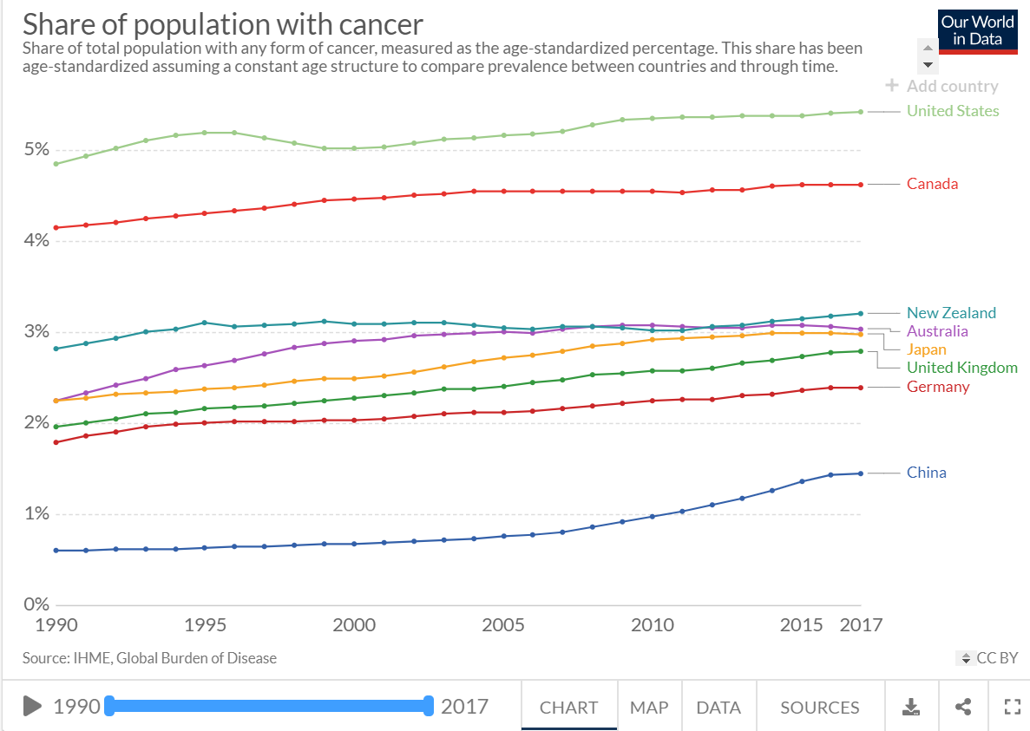

Bar graph has been used in this report to represent different types of Cancer prevalent in 2016 in different countries. In India breast cancer is affecting 0.05% population which is the most common in the year 2016, whereas in New Zealand, prostate cancer is affecting 0.32% of population which is more common than breast cancer.

The line graph shows that the breast cancer has increased by 10% among the population across the world during the year 1990 to 2016. Highest increase was in prostrate cancer which increased by 20%. Stacked area chart in the report, shows that the cancer is most common in age group 50-69. The Bar graph in the report shows death due to different types of cancer across the world in the year 2016. Most of the death in 2016 is due to Tracheal, bronchus and lung cancer in Australia, New Zealand, United states, Canada, Germany, Russia and China whereas in India death due to cancer is mostly contributed by stomach cancer. The death due to testicular cancer are very less compared to other types of cancer in countries like china, Japan, United Kingdom, India and United states in 2016. The unidirectional line graph is used in this report is show five years cancer survival rate in United states of America. The survival rate for cancer in 2007-13 has increased by 17% approximately in comparison to 1970-77. The survival rate for most of the types of cancer have increased over the years whereas for uterus cancer and cervix uteri cancers, it has decreased. The US National Cancer Institute has published data on five-year survival rate of different types of cancer since diagnosis of different sex and race. Survival rate of males from Prostate cancer has increased considerably from 1977(67.8%) to 2013(99.2%).

**Alternatives**-

* Few graphs are repetitive and gives the same information using different kind of presentation. For example: The graph “Share of population with Cancer by type, World, 2017” and the chart “Share of population with cancer types, World” are almost similar and repetitive.
* The report only shows the prevalence of cancer in different parts of the world and does not focus on the reason of the prevalence.
* The graphs shown here are interactive and interesting for the tech savvy audience, but for non-technical people it might be difficult to explore different features of the graphs.
* It does not have information on the effect of cancer for the years 2017 and 2018.
* Information might not be perfect as not all the cases are recorded.
* The report could have also used time series chart showing
* This report only uses the descriptive statistics, it can also use inferential statistics for a better result and understanding such as F-test, Z-test and T-test.

**Conclusion** –

Cancer is a generic term for a large group of diseases that can affect any part of the body and is a leading cause of death worldwide, accounting for an estimated 9.6 million deaths in 2018. This report has taken the topic cancer and have tried to find its extensiveness and impact on the people across the world. The report has been very well written using different bar graphs and line graphs. Time series chart has been used in many instances clearly showing how cancer has been affecting the world population at different interval of time.